Topic 3 – 2: Thinking on the unit circle – Practice
0. Practice memorizing your radian and unit circle coordinates! [todo: put in qr code]

1. [P] See if you can write each definition from memory:
$\sec\left(x\right)=$ $\csc\left(x\right)=$
$\tan\left(x\right)=$ and $\cot\left(x\right)=$

2. [C] Decide what each expression tells you conceptually.
Fill in the blank.
a. $cos(6)$ tells you the ____________________ of a point at _____________________________________.
b. $\sin^{-1}{(0.4)}$ tells you the ____________________________ of a point with _________________________.
c. Draw a picture illustrating where the value $\sin^{-1}{(0.4)}$ might appear on the unit circle.

3. [C] Without a calculator or computer mark the intervals for which each statement is true. Mark them on the circle and write a mathematical expression for all intervals of x-values which make each inequality true.

Your goal is to think about what each statement is saying about points on the unit circle.
- $\sin\left(x\right)<cos⁡(x)$
- cot(x) > 1
- sec(x) < 1
- csc(x) = 1
4. [C]
a. $sec⁡(269.09°)$ is [ choose one ] : ( no calculator! )
a large positive number // a small positive number // a large negative number // a small negative number
Explain in a sentence how you thought about this.
b. Without a calculator, say which is larger: $sec⁡(175°)$ or $csc⁡(5°)$ . Why?
c. Is it possible for $\sin\left(x\right)≥2$ for some x? If so, what x-values will do it? If not, why not?
d. Is it possible for $\sec\left(x\right)≤-2$ for some x? If so, what x-values will do it? If not, why not?
3. FACT: $sin(20°)≈0.34$
Determine what each of the following is (without a calculator) or say “can’t find it with what we know right now”. Use symmtries in the circle to decide.
a). $sin\left(-20°\right)$ b). $sin⁡(40°)$ c). $\sin\left(160°\right)$
d). $\cos\left(70°\right)$ e). $\cos\left(20°\right)$
4. [P] Find all solutions for each on the interval $0<x<2π$
a. $\sin\left(x\right)=\frac{\sqrt{2}}{2}$ b. $\sin\left(\sqrt{x+2}\right)=\frac{\sqrt{2}}{2}$ c. $cos\left(\log_{2}\left(x\right)-1\right)=1$

5. [C] You did this once in the classwork (maybe!). Check to see if you remember how you can think about it.
Consider: $\sin\left(-x\right)=-sin⁡(x)$
a. For an angle x where is the point at angle -x and angle x on the unit circle? (mark them!) Why is sine of one the opposite of the other?
b. How can you “see” this same fact thinking in terms of transformations of the $y=sin⁡(x)$ graph? Sketch the graph, then tell me in a sentence.

Topic 3 – 2: Thinking on the unit circle – Practice Solutions

1. [P] See if you can write each definition from memory:
$\sec\left(x\right)=\frac{1}{cos⁡(x)}$ $\csc\left(x\right)=\frac{1}{sin⁡(x)}$ $\tan\left(x\right)=\frac{\sin\left(x\right)}{cos⁡(x)}$ $\cot\left(x\right)=\frac{cos⁡(x)}{sin⁡(x)}$

2. [C] Decide what each expression tells you conceptually
a. $cos(6)$ tells you the x-coordinate of a point at an angle of 6 radians.

b. Remember that inverse functions reverse input and output.
Regular sine works like this: $\sin\left(angle\right)→y-value$. Inverse sine reverses these inputs and outputs.
So $\sin^{-1}\left(y-value\right)→angle$
Therefore $\sin^{-1}\left(0.4\right)$ tells you the angle of of a point with y-coordinate of 0.4

c. Here’s an approximate picture.

3. [C] Without a calculator or computer mark the intervals for which each statement is true. Mark them on the circle and write a mathematical expression for the interval. Your goal is to think about what each statement is saying about points on the unit circle.

- $\sin\left(x\right)<cos⁡(x)$

- cot(x) > 1

Note: You may think that this should be the same as the last problem since $cot\left(x\right)>1$ can be re-written as $\frac{cos(x)}{sin(x)}>1$ and if you multiply by $sin⁡(x)$ on both sides you (seem to) get $cos\left(x\right)>sin(x)$.

However, note that in the original we’re looking for a positive output from cot(x). That means that either sine and cosine are BOTH positive or they’re BOTH negative. That eliminates the part of the answer from quadrant IV in the last example.

The explanation is that when you multiply by a negative it reverses the inequality. So $\frac{cos(x)}{sin⁡(x)}>1$ only equals $cos\left(x\right)>sin(x)$ when sine was positive (which we see in quadrant 1). If sine were negative we get $cos\left(x\right)<sin(x)$ which is the part we see in quadrant III.

I prefer to not think about it that way. I like to realize my answer is restricted to quadrants I and III and then think about $\frac{larger value (magnitude)}{smaller value \left(magnitude\right)}$ as being greater than 1.

- sec(x) < 1 is $\frac{1}{cos(x)}<1$ which will be true whenever cos(x) is negative, and when cos(x) is positive but larger than 1, which is impossible.

- csc(x) = 1. Is $\frac{1}{sin⁡(x)}=1$ which is when $\sin\left(x\right)=1$.

4. [C]
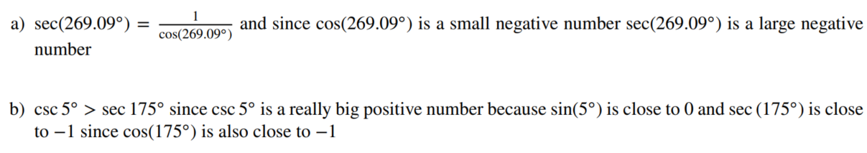
c) Is it possible for $\sin\left(x\right)≥2$ for some x? If so, what x-values will do it? If not, why not?
No. Sine outputs a y-value on the unit circle, so the largest value it can be is 1 when $x=\frac{π}{2}$
d) Is it possible for $\sec\left(x\right)≤-2$ for some x? If so, what x-values will do it? If not, why not?
Yes! Re-write $sec(x)$ as $\frac{1}{cos⁡(x)}$ and it’s asking if $\frac{1}{cos\left(x\right)}≤-2$ . Imagine $cos\left(x\right)=-\frac{1}{2}$ .
Then we’d have $\frac{1}{\left(-\frac{1}{2}\right)}$ which equals -2. Even more conceptually, if we want $\frac{1}{something}≤-2$ we know that the something must be negative and have magnitude smaller than $\frac{1}{2}$. Why smaller? because $\frac{1}{small}=big$, but if it’s a big negative number, $big negative≤-2$. So: if $-\frac{1}{2}≤cos\left(x\right)<0$.
But, of course, that’s not the only place in the unit circle which would work. Let’s solve algebraically as another way to think about it:
First we’ll do it a bit wrong. See if you can spot where things go wrong:
$\frac{1}{cos\left(x\right)}≤-2$ $1≤-2⋅cos(x)$ $-\frac{1}{2}≥cos(x)$. That means $x≥\frac{2π}{3}$ ?
But that doesn’t fit with the picture we drew. Where did the algebra go wrong?
Remember: when you multiply by a negative, the inequality changes direction. We already knew that the output of $cos⁡(x)$ has to be negative. So the first step should look like this:
$\frac{1}{cos\left(x\right)}≤-2$ $1≥-2⋅cos(x)$ $-\frac{1}{2}≤cos(x)$. That means $x≤\frac{2π}{3}$ (and also $x>\frac{π}{2}$ since we know $cos⁡(x)$ has to be negative).
If that all seems a bit fidly, that’s why it’s so helpful to think in terms of pictures in your head! You’re a lot less likely to make little algebra mistakes!
The final answer, including all the bits of the unit circle is:
In intervals, that’s:
$\frac{π}{2}<x≤\frac{2π}{3}$ and $\frac{5π}{6}≤x<π$

5. [P] Find all solutions for each on the interval $0<x<2π$
a. $\sin\left(x\right)=\frac{\sqrt{2}}{2}$
You can, of course, take the inverse sine here, which is something we’ll do later. Right now I want you to think conceptually about the meaning of the equation. This is saying: “what angle(s) x will output a y-value of $\frac{\sqrt{2}}{2}$ on the unit circle?”
You can only do this if you know your unit circle values.
If you don’t, let’s start memorizing a bit each day.
The solutions are $x=\frac{π}{4}$ or $\frac{3π}{4}$.
b. $\sin\left(\sqrt{x+2}\right)=\frac{\sqrt{2}}{2}$ This is the same idea, but think of the entire $\sqrt{x+2}$ as the angle.
So we have that ANGLE $=\frac{π}{4} or\frac{3π}{4}$ so: $\sqrt{x+2}=\frac{π}{4}$ or $\sqrt{x+2}=\frac{3π}{4}$
Solving these gives: $x={\left(\frac{π}{4}\right)}^{2}-2$ or $x={\left(\frac{3π}{4}\right)}^{2}-2$
c. $cos\left(\log_{2}\left(x\right)-1\right)=1$ Same idea: here if $\cos\left(ANGLE\right)=1$ we know $ANGLE=0$
But $ANGLE=\log_{2}{(x)}-1$ so: $\log_{2}\left(x\right)-1=0$
Solving gives: $\log_{2}\left(x\right)=1$ $2^{1}=x$ so $x=2$
5. [C] FACT: $sin(20°)≈0.34$
Determine what each of the following is (without a calculator) or say “can’t find it with what we know right now”
a). $sin\left(-20°\right)=-0.34$
b). $sin⁡(40°)$ can’t find this with what we know so far (at least not obviously by looking at the picture)
c). $\sin\left(160°\right)=0.34$
d). $\cos\left(70°\right)=0.34$
e). $\cos\left(20°\right)$ might seem like we can’t find it. But let’s use the pythagorean theorem. If we say $\cos\left(20°\right)=k$ we know that ${0.34}^{2}+k^{2}=1$. This gives $k=\sqrt{1-{0.34}^{2}}$

5. Consider: $\sin\left(-x\right)=-sin⁡(x)$
a. For an angle x where is the point at angle -x and angle x on the unit circle? (mark them!) Why is sine of one the opposite of the other?
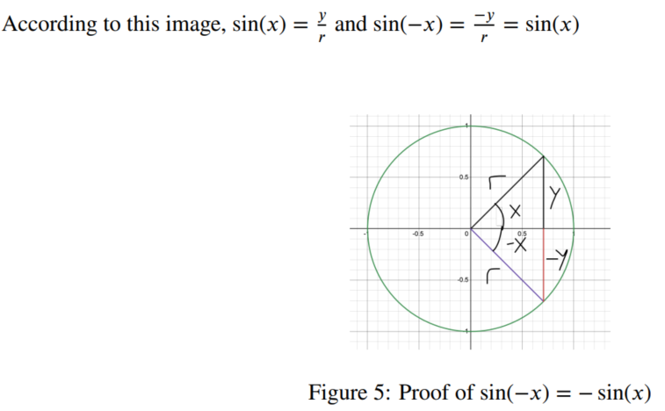
b. How can you “see” this same fact thinking in terms of transformations of the $y=sin⁡(x)$ graph? Sketch the graph, then tell me in a sentence.

We can see the same idea using transformations of the graph $y=sin(x)$
The equation $\sin\left(-x\right)=-sin⁡(x)$ can be interpreted as saying “horiziontally reflecting the sine function” gives the same graph as “vertically reflecting sine”. Let’s check it. Here’s $y=sin⁡(x)$
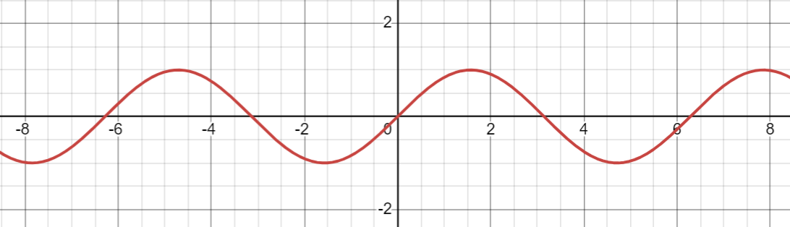
Imagine horizontally reflecting it. What’s it look like?
Imagine vertically reflecting it. What’s it look like?
Are they the same?

